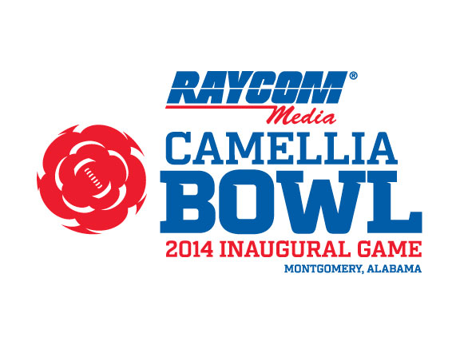
POST-GAME NOTES
RAYCOM MEDIA CAMELLIA BOWL NOTES
- Bowling Green (8-6) defeated South Alabama (6-7) 33-28 in the inaugural Raycom Media Camellia Bowl at historic Cramton Bowl in Montgomery. The attendance for the inaugural event was 20,256.

- Prior to kickoff, the official ribbon cutting for the Raycom Media Camellia Bowl took place at midfield with Johnny Williams (Camellia Bowl Executive Director), Paul McTear (President and CEO of Raycom Media), Todd Strange (Mayor of Montgomery), Elton Dean (Chairman of the Montgomery County Commission), Dr. John Steinbrecker (Mid-American Conference Commissioner) and Karl Benson (Sun Belt Conference Commissioner).

- Bowling Green (orange jerseys, white pants and white helmets) won the toss and deferred to the second half … South Alabama (gray jerseys, blue pants and white helmets) received the kickoff in the south end zone.

- The official kickoff time was 8:20 p.m. (CT) … BGSU junior kicker Anthony Farinella handled the first kickoff in Raycom Media Camellia Bowl history … South Alabama ran the first play from scrimmage in Raycom Media Camellia Bowl history … USA quarterback Brandon Bridges threw an incomplete pass, which was intended for Shavarez Smith … South Alabama went three-and-out on the first possession in Camellia Bowl history.

- Bowling Green recorded the initial first down in Raycom Media Camellia Bowl history as James Knapke completed a 6-yard slant pass to Ronnie Moore on a third-and-3 from the BGSU 42-yard line.

- Bowling Green led 20-7 at halftime … the team leading at halftime is 5-0 so far in the 2014 College Football Bowl season.

BOWLING GREEN NOTES
- Bowling Green quarterback James Knapke was named the 2014 Bart Starr MVP Award winner. The redshirt quarterback completed 25-of-39 passes for 368 yards and two TDs in leading the Falcons to a 33-28 win over South Alabama. He threw the game-winning 78-yard TD pass to freshman receiver Roger Lewis with 1:04 left in the game. Knapke led the Falcons to a pair of TD drives on the first two possessions in the first quarter as BGSU led 14-0 with just under eight minutes left in the first quarter.

- Knapke had four completions of more than 40 yards in the win over South Alabama … in addition to his game-winning 78-yard TD pass to Lewis, Knapke had a 44-yard TD pass to Lewis in the first quarter … Knapke also had a 53-yard completion to Gehrig Dieter and a 42-yard completion to Ronnie Moore.

- The Falcons had a pair of 100-yard receivers in the win over South Alabama … redshirt sophomore Gehrig Dieter had a game-high seven catches for 108 yards in the win … freshman Roger Lewis caught four passes for a game-high 137 yards.

- Lewis averaged 34.3 yards per catch in the win over South Alabama. Lewis caught four passes for 137 yards and two TDs in the win, including the 78-yard game-winning TD with 1:04 left in the game. He also caught the first TD pass in Camellia Bowl history with a 44-yard TD catch in the first quarter.

- Bowling Green scored the first touchdown in Raycom Media Camellia Bowl history when Knapke threw a 44-yard touchdown pass to Lewis to give the Falcons a 7-0 lead … the scoring drive covered seven plays and 65 yards and used 2:21 off the clock … the 44-yard TD pass came with 12:59 remaining in the first quarter.

- Bowling Green scored the first rushing touchdown in Raycom Media Camellia Bowl history when redshirt junior Travis Greene scored on a 1-yard TD run with 7:17 left in the first quarter … the touchdown was set up by a 53-yard pass from Knapke to Dieter giving the Falcons a first-and-goal at the USA 4-yard line … Green finished with 20 rushing attempts for 41 yards and two TDs for the Falcons.

- Bowling Green has at least one rushing touchdown in 14 consecutive games, it’s longest since a 15-game streak from October 6, 2001-November 2, 2002.

- Bowling Green redshirt junior kicker Tyler Tate made the first field goal in Raycom Media Camellia Bowl history with a 39-yard FG with 6:49 left in the second quarter … Tate also set the BGSU single-season record with 22 made field goals this year.

- Bowling Green sophomore Ronnie Moore was ejected for targeting at the 13:10 mark of the third quarter following his hit on USA punt returner Jereme’ Jones … Moore was the Falcons’ second-leading receiver with five catches for 51 yards in the game.

- Bowling Green is now 5-7 in its 12 bowl games after a 33-28 win over South Alabama on Saturday … the win snapped a four-game bowl losing streak for the back-to-back MAC Eastern Division champions.
SOUTH ALABAMA NOTES
- South Alabama took its only lead of the game on junior running back Terrance Timmons 3-yard TD run with 1:20 left in the game … Timmons go-ahead score capped an 8-play, 73-yard drive that took 2:53 off the clock … South Alabama trailed 14-0 in the first quarter and 20-7 at halftime before its near second-half comeback.

- South Alabama senior Kendall Houston scored the first touchdown in Jaguars bowl history with a 44-yard touchdown run with 5:42 left in the first quarter to cut the deficit to 14-7 … Houston’s 44-yard run was the longest his career for the Jaguars.

- Houston was the team’s leading rusher with five carries for 53 yards (10.6 yards) and one touchdown in the loss to the Falcons.

- South Alabama junior tight end DeMarrion Buford-Hughes had an 18-yard touchdown reception with 11:23 remaining the game to cut the BGSU lead top 27-21 … It was his first career TD catch for the Jaguars.

- South Alabama senior inside linebacker Maleki Harris set the South Alabama single game record for total tackles and tied the record for solo tackles against the Falcons … Harris finished with 18 tackles and 12 solo tackles in the game … He also added three tackles for loss (-19 yards), one sack (-14 yards) and one quarterback pressure.

- In addition to Harris, senior free safety Terrell Bigham recorded 12 tackles for the Jaguars defense … Bigham had five solo tackles and seven assists against the Falcons.

- South Alabama played its first bowl game in school history with its 33-28 loss to Bowling Green in the Raycom Media Camellia Bowl. The Jaguars have only been playing football since 2009 and are in the second year as an FBS member.

